**Automation of Golf Ops Processes**

**Process Step-by-step Guide**

**Step 1: Unzipping the “Archieve.zip” file**

You will find these 3 **.html** files inside the “**templates**” folder.

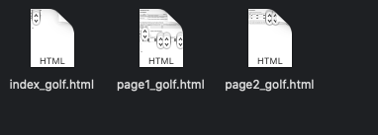

**Step 2: Main webpage for Golf Competition**

Open “**index_golf.html**” file with any browser

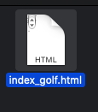

**Step 3: Enter initial values to set up a Golf Competition**

Enter all the respective values & click “**Submit**” button

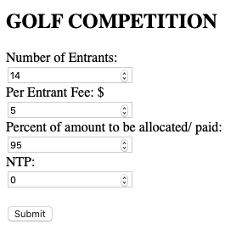

**Step 4: Review Fund Statistics**

Go through all the fund values provided on the next webpage.

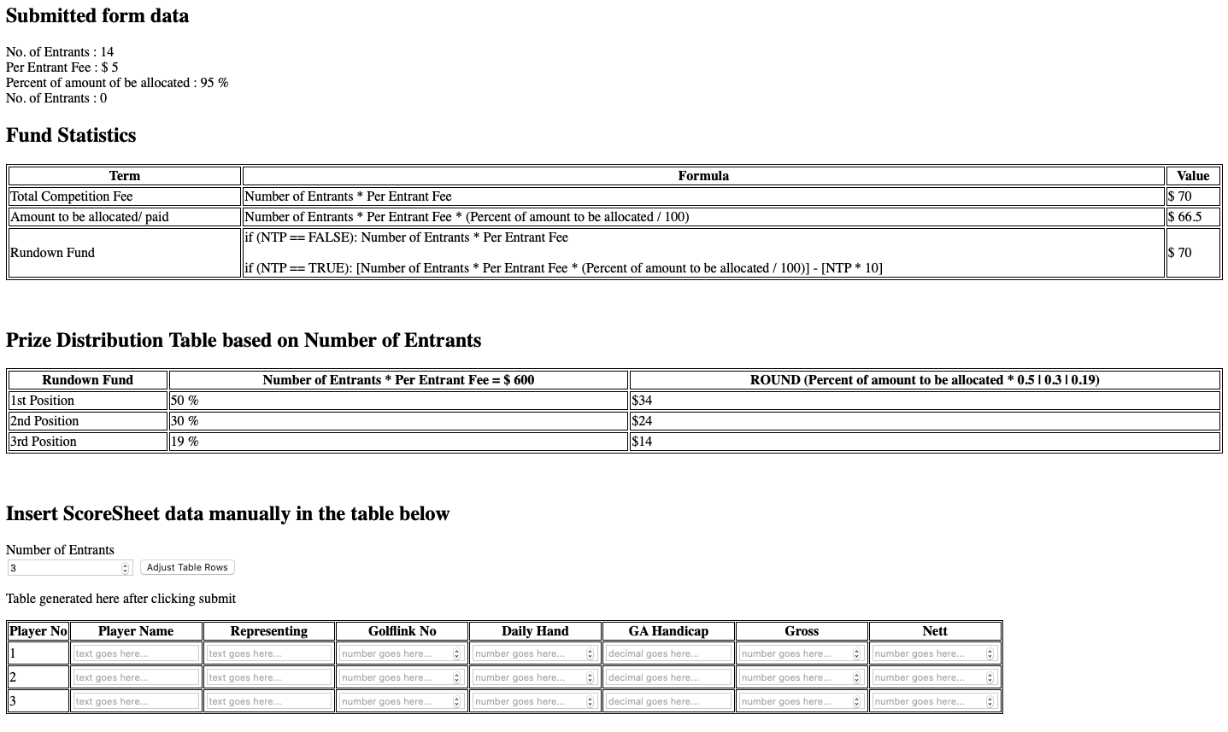

**Step 5: Fill up the Score Sheet**

Change the number of Entrants & click “**Adjust Table Rows**”

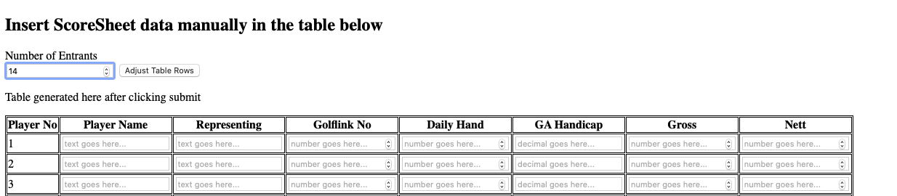

Now, fill up the **Score Sheet** manually with all the Players’ score details.

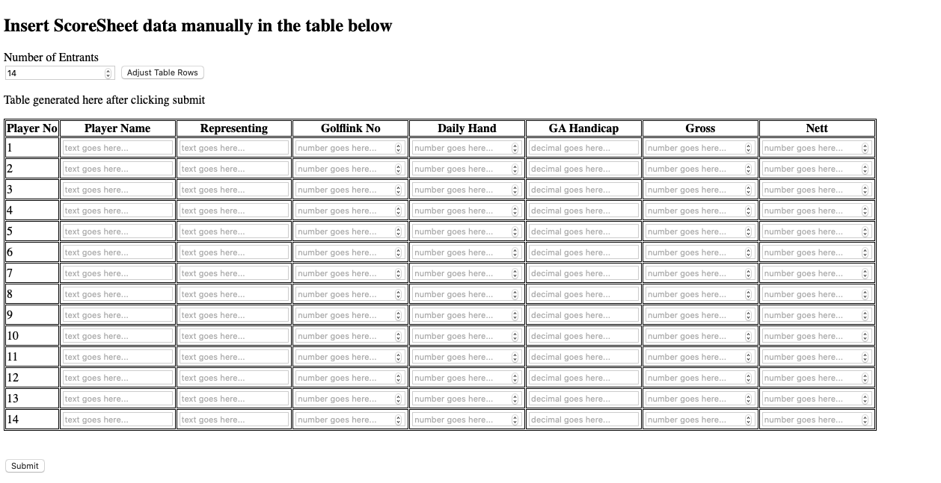

After filling up **Score Sheet**, click “**Submit**” button

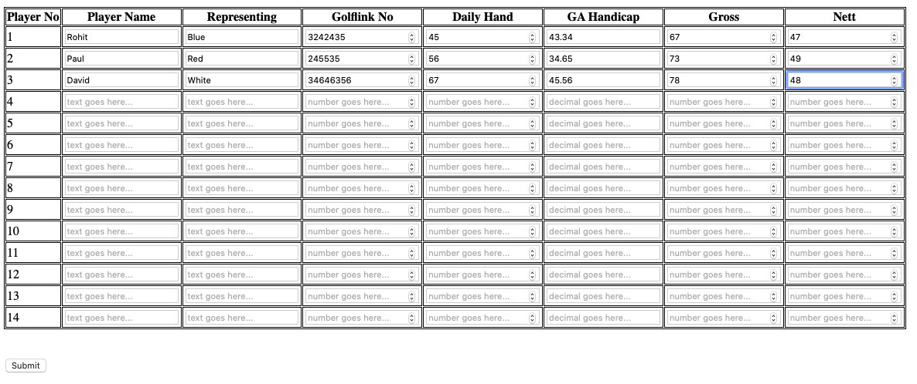

**Step 6: Review of the final results**

Finally, we can see the result of **Golf Competition** with all **Player Names** along with their **Position, Score, and Prize Money**.

